Maidstone and Tunbridge Wells NHS Trust

Trust contact details

**Tunbridge Wells Hospital at Pembury**

Tonbridge Road, Pembury, Tunbridge Wells,

Kent TN2 4QJ

**Switchboard:**

01892 823535

**Trust websites:**

www.mtw.nhs.uk

www.me.mtw.nhs.uk

Foundation Training Programme Directors

Dr James Ironside

Dr Katy Davies

**Director of Medical Education**

Dr Derek Harrington

**Strategic Medical Education Manager**

Chris White

**Medical Education Manager**

Anita Mann

**Medical Staffing Manager**

TBC

**Foundation Programme Manager**

Anita Mann

**Foundation Programme Administrator**

Alexandra Davis

Phoebe Aldrich

Facilities - Postgraduate Centre (Location and resources)

The Education & Training Centre is the hub of the hospital as far as the doctors in training are concerned and we pride ourselves in the way we look after our Junior Doctors. Our Centre provides quality space and equipment for teaching, simulation training and meetings and friendly staff are active in sending teaching reminders and monitoring ePortfolio progress.

Simulation facilities – Sim man 3G, 2 Paediatric Sims (child and baby) and a ‘Sim Mum’, Clinical skills rooms for use in training.

There is a Laparoscopic training Centre located within the Maidstone Academic Centre.

 

We think it to be one of the best designed and equipped Education Centres in the region.

Facilities - Accommodation (Info about pricing, location etc)

Accommodation just 1 mile from the Tunbridge Wells Hospital is available for all our F1 doctors.

Communal living creates a great atmosphere among fellow F1s who often make friends for life.

Social activities

Outside of work there is a vibrant social life including ‘Pay Day’ themed outings and other regular mess nights organized by F1s. Foundation Doctors also organise the Winter and Summer Ball and annual cricket match against the Consultants.

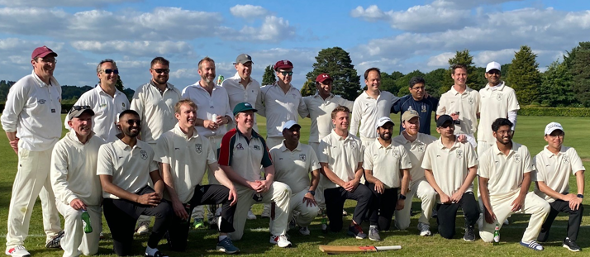

Doctors’ Mess

The Doctors Mess has four F1 presidents and they arrange social events taking place throughout the year. The Mess is located close to the Education & Training Centre, on level -2.

Library Facilities

There is 24/7 access to the Library, situated in the Academic Centre providing access to traditional (textbooks, journals, search skills training) and internet-based resources (e-journals, e-books, Up To Date, Netvibes, Clinical Key and Anatomy TV). Free use of online revision packages including ‘OnExamination’. Doctors in training are actively involved in all decision making on resources. Friendly staff provide tailored Knowledge Services and are highly responsive to Junior Doctor needs.

Medical Humanities: Foundation Doctors can attend monthly virtual Book Club and a Film Club held in the spacious auditorium within the Maidstone Academic Centre.

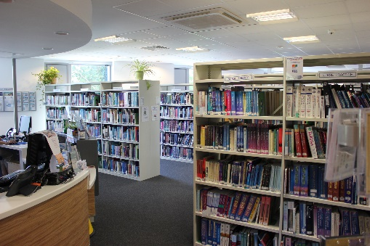

I.T Facilities

Modern IT facilities throughout the Hospital and 24/7 Wi-Fi access available throughout the Hospital.

Transport Links

The Tunbridge Wells Hospital (TWH) is situated in Kent, three miles from the centre of Royal Tunbridge Wells with regular buses running to and from the town centre. Direct trains run from Tunbridge Wells to London Charing Cross and London Bridge in under an hour. You can also catch the bus directly to Brighton in 1hr 30min. It is 15 minutes from the M25. With excellent transport links, Tunbridge Wells lies within easy reach of the South Coast, Gatwick Airport and the Channel Tunnel.

Local amenities/attractions

Royal Tunbridge Wells (an old Royal Spa town) is renowned for its superb range of high street and boutique shops, restaurants, cafes, pubs and bars. Three theatres mean access to regular plays, dance and comedy performances. There is easy access to the gym, cinema, bowling and many retail outlets at Knights Park Leisure Complex. Tesco supermarket is only 10 minutes’ walk away and there is a Costa Coffee and W H Smiths located within the hospital.

The hospital is situated in an Area of Outstanding Natural Beauty with plenty of opportunities to walk, boat and bike ride including Bewl Water Lake, The Hop farm and a number of vineyards, castles, gardens and stately homes.

Parking Arrangements

Parking permits are available for on-site parking.

Accolades/achievements of the Trust

National Quality Accreditation awarded to MTW, following an assessment by a team of external senior healthcare professionals, Maidstone and Tunbridge Wells NHS Trust’s Cancer and Haematology Directorate, based at Kent Oncology Centre at Maidstone Hospital, has been accredited by CHKS.

Maidstone & Tunbridge Wells NHS Trust hosts the Kent Oncology Centre providing specialist cancer services to around 2 million people across Kent and East Sussex, the forth largest oncology service in the country. The Trust offers PET CT services in a new, dedicated building.

Tunbridge Wells Hospital is a Private Finance Initiative (PFI) hospital, providing mainly single bedded, en-suite accommodation for inpatients in a modern, state of the art environment. It is a designated Trauma Unit, undertakes the Trust’s emergency surgery and is the main site for Women and Children and Orthopaedic services.

Any additional information

Our hospitals offer an extremely friendly learning environment which ensures that you are exposed to all aspects of Acute Medicine and Acute Surgery. Our rotas are designed to offer you a broad based learning experience. The fact that many medical students and junior doctors have returned to the Hospital as part of their further training is a testament to the way we treat junior staff here.

Foundation specific - Induction/shadowing arrangements

F1 Doctors join the Trust for a week of induction and shadowing prior to joining the wards on the first Wednesday in August, with a social event on the weekend before starting.

We have a comprehensive Trust induction day for F2 Doctors, before their Departmental Induction the following day.

Foundation specific – Tasters

We offer a number of Taster Week timetables in various specialties throughout the Trust.

Foundation specific – Simulation

Simulation has a high profile with in the Trust and has had a significant investment. There is a dedicated Simulation Faculty responsible for running compulsory training sessions for all foundation Doctors. We have received excellent feedback from current Junior Doctors and the training has proven to be very popular. There are clinical skills labs and a dedicated Simulation training room.

Foundation Doctor Forums

There are regular Junior Doctor Voice events for doctors in training to raise any issues or concerns in an informal setting.

Foundation specific - educational and clinical supervision

Every doctor in training has an Educational Supervisor, who oversees their progress through their rotation and a Clinical Supervisor in each attachment. Every doctor in training is formally assessed through the Faculty Meetings that occur three times a year with formal or informal feedback as appropriate.

Foundation specific - teaching programme

As a Trust we look after 63 F1 and 54 F2 Doctors. We have established Foundation Teaching Programmes for Foundation Doctors.

The Foundation Year 1 Programme in Tunbridge Wells is directed by Dr James Ironside, with Dr Katy Davies looking after the F2 Programme.

The Foundation Year 1 programme in Maidstone is directed by Dr Bet Mishra, with Dr Amit Saha looking after the F2 programme.

We are a friendly DGH offering a variety of posts. These include: Acute Medicine, Anaesthetics, Cardiology, Diabetes & Endocrinology, Emergency Medicine, Gastroenterology, General Surgery, Geriatric Medicine, GP, Obstetrics & Gynaecology, Orthogeriatrics, Otolaryngology (ENT), Paediatrics, Psychiatry, Respiratory Medicine and Trauma & Orthopaedics. Please see individual placement descriptors for full details.

Doctors in training completing a Psychiatry placement will be working at a Kent and Medway Partnership Trust site.

A free shuttle bus services operates for staff to travel between sites.

There is protected teaching for F1s at lunchtime on Wednesdays and Surgical Teaching taking place on Thursdays, for F2 Doctors, protected teaching occurs on Tuesday afternoons. Other teaching opportunities are available in each of the departments and a list of these activities will be available on the intranet. In addition to this, Medical Grand Round occurs weekly on Thursday lunchtimes and Clinical Governance sessions are arranged for each month.



Foundation specific - any additional information

Maidstone & Tunbridge Wells Trust is a great place to work and learn. The Trust believes in giving 100% to our doctors in training, because these are our future Consultants.

Our aim is to inspire excellence in Medical Education across the Trust and this is at the heart of all we do. We pride ourselves on helping our doctors in training throughout their time with us. Whether you require support with ePortfolio, Study Leave, Simulation training, admin etc. we are here to assist in any way we can.

What our Foundation Doctors say:

*“The Education Centre have state of the art facilities & an enthusiastic and knowledgeable team that is standing by to support you in whatever way they can”*

*“Good level of independence and support in making clinical decisions. Very friendly working atmosphere and a fun place to start the F1 year!”.*