Maidstone and Tunbridge Wells NHS Trust

Trust contact details

Maidstone Hospital

Hermitage Lane, Maidstone, Kent, ME16 9QQ

**Trust switchboard:**

01622 729000

**Trust website:**

www.mtw.nhs.uk

www.me.mtw.nhs.uk

Foundation Training Programme Directors

Dr Bet Mishra

Dr Amit Saha

**Director of Medical Education**

Dr Derek Harrington

**Strategic Medical Education Manager**

Chris White

**Medical Education Manager**

Anita Mann

**Medical Staffing Manager**

TBC

**Foundation Programme Manager**

Anita Mann

**Foundation Programme Administrator**

Alexandra Davis

Shayleigh Tidman

Facilities - Postgraduate Centre (Location and resources)

The Academic Centre is situated at the front of the Hospital. The Centre is the hub of the Hospital as far as the Doctors in training are concerned and we pride ourselves in the way we look after our Junior Doctors. The Academic Centre has a 180 seated auditorium, training rooms with audio visual equipment, dedicated Simulation and Clinical Skills rooms, a Library and a dining area. State of the art Simulation facilities – Sim man 3G, 2 Paediatric Sims (child and baby) and a ‘Sim Mum’, Clinical skills rooms and Wet Lab for use in training. There is a Laparoscopic training Centre located within the Maidstone Academic Centre.

We think it to be one of the best designed and equipped Education Centres in the region.

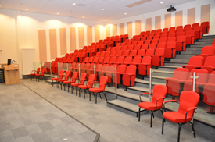 

Facilities - Accommodation (Info about pricing, location etc)

Single accommodation, just a 7 minute walk from the hospital is available for all our F1 doctors. Communal living creates a great atmosphere among fellow F1s who often make friends for life.

Social activities

We have an active Doctors’ Mess Committee that arrange several social events throughout the year as well as the Winter and Summer Ball. These are activities specifically for all doctors. There is also an annual cricket match against the Consultants.

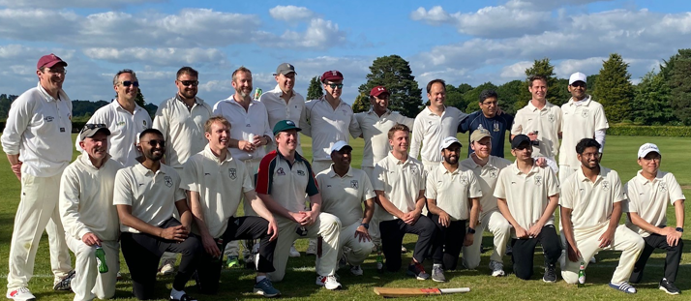

Doctors’ Mess

The Doctors Mess has four F1 presidents and they arrange social events taking place throughout the year. The Doctors’ Mess, located in the Blue Zone, Level 2, just next to ICU, has a sitting room, a quiet room, a games room and a kitchen.

Library facilities

There is 24/7 access to the Library, situated in the Academic Centre providing access to traditional (textbooks, journals, search skills training) and internet-based resources (e-journals, e-books, Up To Date, Netvibes, Clinical Key and Anatomy TV). Free use of online revision packages including ‘OnExamination’. Doctors in training are actively involved in all decision making on resources. Friendly staff provide tailored Knowledge Services and are highly responsive to Junior Doctor needs.

Medical Humanities: Foundation Doctors can attend monthly virtual Book Club and a Film Club held in the spacious auditorium within the Maidstone Academic Centre.

I.T facilities

Modern IT facilities throughout the Hospital and 24/7 Wi-Fi access available throughout the Hospital and the Academic Centre.

Transport links

M20 junction 5 (1 mile) Barming station (half mile) Ebbsfleet international (30 minutes).

Local amenities/attractions

There are several take-away food outlets and a Tesco Express immediately adjacent to the hospital, in addition to the Costa Coffee and M&S located within the hospital. There are also other shops, restaurants, pubs, gyms and leisure centres within easy reach.

Maidstone has its own shopping complex, many restaurants, night clubs, cinema and theatre with easy access from the hospital.

Leeds Castle, Mote Park, the Hop Farm and Bluewater are local attractions open all year round.

Parking arrangements

Parking permits are available for on-site parking.

Accolades/achievements of the Trust

National Quality Accreditation awarded to MTW, following an assessment by a team of external senior healthcare professionals, Maidstone and Tunbridge Wells NHS Trust’s Cancer and Haematology Directorate, based at Kent Oncology Centre at Maidstone Hospital, has been accredited by CHKS.

Maidstone & Tunbridge Wells NHS Trust hosts the Kent Oncology Centre providing specialist cancer services to around 2 million people across Kent and East Sussex, the forth largest oncology service in the country. The Trust offers PET CT services in a new, dedicated building.

The site also has a state of art Birth Centre, a £3 million dedicated ward for respiratory services, a Paediatric Assessment Unit and a dedicated Centre for Trauma and Orthopaedic Surgery.

Any additional information

Our hospitals offer an extremely friendly learning environment which ensures that you are exposed to all aspects of Acute Medicine and Acute Surgery. Our rotas are designed to offer you a broad based learning experience. The fact that many medical students and junior doctors have returned to the hospital as part of their further training is a testament to the way we treat junior staff here.

Foundation specific - Induction/shadowing arrangements

F1 Doctors join the Trust for a week of induction and shadowing prior to joining the wards on the first Wednesday in August, with a social event on the weekend before starting.

We have a comprehensive Trust induction day for F2 Doctors, before their Departmental Induction the following day.

Foundation specific – Tasters

We offer a number of Taster Week timetables in various specialties throughout the Trust.

Foundation specific – Simulation

Simulation has a high profile with in the Trust and has had a significant investment. There is a dedicated Simulation Faculty responsible for running compulsory training sessions for all Foundation Doctors. We have received excellent feedback from current Junior Doctors and the training has proven to be very popular. There are clinical skills labs and a dedicated Simulation training room.

Foundation Doctor Forums

There are regular Junior Doctor Voice events for doctors in training to raise any issues or concerns in an informal setting.

Foundation specific - educational and clinical supervision

Every doctor in training has an education supervisor, who oversees their progression through their rotation

and a clinical supervisor in each attachment. Every doctor in training is formerly assessed through the Faculty Meetings that occur three times a year with formal or informal feedback as appropriate.

Foundation specific - teaching programme

As a Trust we look after 63 F1 and 54 F2 doctors. We have established Foundation Teaching programmes as we were one of the pilot Trusts for both F1s and F2s.

The Foundation Year 1 programme in Maidstone is directed by Dr Bet Mishra, with Dr Amit Saha

looking after the F2 programme.

The Foundation Year 1 programme in Tunbridge Wells is directed by Dr James Ironside, with Dr Katy Davies looking after the F2 programme.

We are a friendly DGH offering a variety of posts, these include: - Acute Medicine, Anaesthetics, Cardiology, Diabetes & Endocrinology, Emergency Medicine, Gastroenterology, Geriatric Medicine, GP, Haematology, Medicine, Orthogeriartics, Paediatrics, Psychiatry, Respiratory, Stroke Medicine, Trauma & Orthopaedics and Urology. Please see individual placement descriptors for full details.

The following specialties are based at the Tunbridge Wells Hospital in Pembury, and therefore if you chose a programme that includes one of these you will be based on the Tunbridge Wells site for the duration of that rotation; General Surgery, Orthogeriatrics, Paediatrics, Trauma & Orthopaedics.

Doctors in training completing a Psychiatry placement will be working at a Kent and Medway Partnership Trust site.

A free shuttle bus services operates for staff to travel between sites.

There is protected teaching for F1s at lunchtime on Tuesdays and Thursdays, and for F2 Doctors teaching occurs on Thursday afternoons.

Other teaching opportunities are available in each of the departments and a list of these activities will be available on the intranet. In addition to this, Medical Grand Round occurs weekly on Monday lunchtime and Clinical Governance sessions are arranged for each month.



Foundation specific - any additional information

Maidstone & Tunbridge Wells Trust is a great place to work and learn. The Trust believes in giving 100% to our doctors in training, because these are our future Consultants.

Our aim is to inspire excellence in Medical Education across the Trust and this is at the heart of all we do.

We pride ourselves on helping our doctors in training throughout their time with us. Whether you require support with ePortfolio, Study Leave, Simulation training, admin etc. we are here to assist in any way we can.

We have several award ceremonies over the year including; an Innovation prize and an Art prize.

What our Foundation Doctors say:

*“The Education Centre have state of the art facilities & an enthusiastic and knowledgeable team that is standing by to support you in whatever way they can”*

*“Good level of independence and support in making clinical decisions. Very friendly working atmosphere and a fun place to start the F1 year!”.*